Class 11th
AI UNIT 1 :-Introduction: Artificial Intelligence for Everyone

A. Multiple Choice Questions (MCQs)
Q1. Who is often referred to as the "Father of AI"?
Options:
a. Alan Turing
b. John McCarthy
c. Marvin Minsky
d. Herbert A. Simon
Answer: b. John McCarthy
Q2. In which year was the term "Artificial Intelligence" first used by John McCarthy?
Options:
a. 1930
b. 1955
c. 1970
d. 2000
Answer: b. 1955

Q3. What does the term "Data is the new oil" imply?
Options:
a. Data is as valuable as oil.
b. Data is used as fuel for machines.
c. Data is a non-renewable resource.
d. Data and oil are unrelated.
Answer: a. Data is as valuable as oil.

Q4. Divya was learning neural networks. She understood that there were three layers in a neural network. Help her identify the layer that does processing in the neural network.
Options:
a. Output layer
b. Hidden layer
c. Input layer
d. Data layer
Answer: b. Hidden layer

Q5. Which category of machine learning occurs in the presence of a supervisor or teacher?
Options:
a. Unsupervised Learning
b. Reinforcement Learning
c. Supervised Learning
d. Deep Learning
Answer: c. Supervised Learning
Q6. What does Deep Learning primarily rely on to mimic the human brain?
Options:
a. Traditional Programming
b. Artificial Neural Networks
c. Machine Learning Algorithms
d. Random Decision Making
Answer: b. Artificial Neural Networks
Q7. What is the role of reinforcement learning in machine learning?
Options:
a. Creating rules automatically
b. Recognizing patterns in untagged data
c. Rewarding desired behaviors and/or penalizing undesirable ones
d. Mimicking human conversation through voice or text
Answer: c. Rewarding desired behaviors and/or penalizing undesirable ones

Q8. Which AI application is responsible for automatically separating emails into "Spam" and "Not Spam" categories?
Options:
a. Gmail
b. YouTube
c. Flipkart
d. Watson
Answer: a. Gmail

B. Fill in the Blanks
1. To determine if a machine or application is AI-based, consider its ability to perform tasks that typically require human intelligence.
2. Artificial intelligence (AI) enables a machine to carry out cognitive tasks typically performed by humans.
3. Supervised, unsupervised, and reinforcement learning are three categories of Machine Learning.
4. Deep Learning is a subset of artificial intelligence that is entirely based on artificial neural networks.
5. Machine learning can be used for online fraud detection to make cyberspace a safer place.

C. True or False
1. Chatbots like Alexa and Siri are examples of virtual assistants.
Answer: True

2. Supervised learning involves training a computer system without labeled input data.
Answer: False
Explanation: Supervised learning uses labelled data, where the correct output is already known during training.
3. Unstructured data can be easily analyzed using traditional relational database techniques.
Answer: False
Explanation: Unstructured data has no predefined format and requires specialized tools and techniques for analysis.
4. Deep learning typically requires less time to train compared to machine learning.
Answer: False
Explanation: According to the PDF, deep learning takes longer time to train than traditional machine learning.
5. Machine learning is not used in everyday applications like virtual personal assistants and fraud detection.
Answer: False
Explanation: Machine learning is widely used in applications such as virtual assistants, recommendation systems, and online fraud detection.
D. Short Answer Questions
Q1. How is Machine Learning related to AI?
Answer:-Machine Learning (ML) is a subset of Artificial Intelligence (AI). AI is the broader concept of making machines intelligent, while ML enables machines to learn from data and improve their performance without being explicitly programmed. Machine learning helps AI systems recognize patterns, make predictions, and take decisions automatically.

Q2. Define Machine Learning.
Answer:-Machine Learning (ML) is a branch of Artificial Intelligence that enables computers to learn from data, identify patterns, and make decisions or predictions without being explicitly programmed. The more data the machine receives, the better it learns and improves its accuracy.

Q3. What do you mean by Reinforcement Learning? Write any two applications of Reinforcement Learning at school.
Answer:-Reinforcement Learning (RL) is a type of Machine Learning in which an agent learns by interacting with its environment. It receives rewards for correct actions and penalties for incorrect actions, helping it learn the best way to achieve a goal.
Any two applications of Reinforcement Learning at school:
- AI-based learning apps that reward students for answering questions correctly and adjust the difficulty level based on performance.
- Educational robots that learn the best path to move around classrooms or school campuses while avoiding obstacles.

Q4. How do you understand whether a machine/application is AI-based or not? Explain with the help of an example.
Answer:
A machine or application is AI-based if it can:
- Learn from data or experience.
- Recognize patterns.
- Make decisions or predictions.
- Improve its performance over time without being explicitly programmed for every task.
Example:
Google Maps is an AI-based application because it analyzes real-time traffic data, predicts the fastest route, estimates travel time, and suggests alternative routes based on changing road conditions.
E. Long Answer Questions
Q1. Define Data. Briefly explain the types of data.
Answer:-Introduction:-Data is the foundation of Artificial Intelligence (AI). Every AI system requires data to learn patterns, make decisions, and solve real-world problems. The quality and type of data directly affect the performance of an AI system.
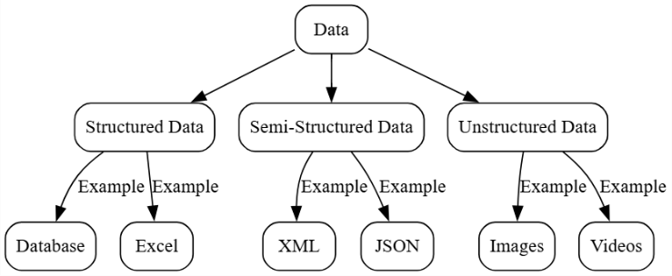
1. Definition of Data
Data is a collection of raw facts, figures, observations, or measurements that can be processed to produce meaningful information. Data may be in the form of numbers, text, images, audio, or videos.
2. Structured Data
Structured data is organized in a predefined format such as rows and columns. It is easy to store, search, and analyze using databases and spreadsheets.
Examples: Student records, bank transactions, employee details, examination marks.
3. Semi-Structured Data
Semi-structured data does not follow a fixed tabular format but contains tags or labels that help organize the information. It is partially structured and easier to process than unstructured data.
Examples: XML files, JSON files, HTML documents.
4. Unstructured Data
Unstructured data has no predefined format or structure. It is difficult to organize and analyze using traditional methods, so AI techniques are often used to process it.
Examples: Images, videos, audio recordings, emails, and social media posts.
Conclusion
Data is essential for training AI and Machine Learning models. The more accurate and relevant the data, the better the AI system can learn, make predictions, and improve its performance.

Q2. What is Deep Learning, and how does it differ from traditional Machine Learning?
Answer:-Introduction:-Deep Learning is one of the most advanced technologies in Artificial Intelligence. It enables computers to learn complex patterns from large amounts of data and perform tasks such as image recognition, speech recognition, and language translation with high accuracy.
- Definition of Deep Learning
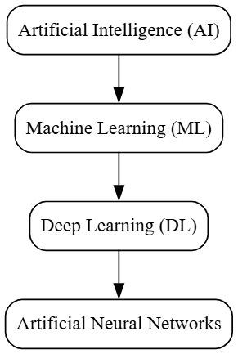
Deep Learning is a subset of Machine Learning that uses Artificial Neural Networks (ANNs) with multiple hidden layers to automatically learn features from large datasets and make intelligent decisions.
2. Working of Deep Learning
Deep Learning models process data through multiple layers of artificial neurons. Each layer extracts important features from the input data, allowing the model to solve complex problems with high accuracy.
3. Difference in Feature Extraction
Traditional Machine Learning requires manual feature extraction, where humans identify important features before training the model. In contrast, Deep Learning automatically learns useful features from the data without human intervention.
4. Difference in Data and Performance
Traditional Machine Learning works well with small or medium-sized datasets and requires less computational power. Deep Learning requires large datasets and powerful hardware, but it provides better accuracy for complex tasks.
5. Applications of Deep Learning
Deep Learning is widely used in face recognition, voice assistants, self-driving cars, medical image analysis, language translation, and recommendation systems because of its ability to learn complex patterns from data.
Conclusion
Deep Learning is an advanced form of Machine Learning that uses deep neural networks to learn from large datasets automatically. Although it requires more data and computational resources than traditional Machine Learning, it provides higher accuracy and is widely used in modern Artificial Intelligence applications.

